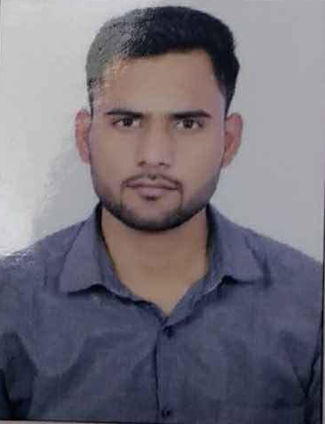


Amir8373khan@gmail.com


+91-6396106575,



Flat no. 304, B. No. 64/38
Okhla, New Delhi

SKILLS

- MS Excel
- MS PowerPoint
- Time management
- Customer Service
- Conflict Resolution
- Team handling
- Team Reporting

AMIR KHAN
Assistant Manager

EXPERIENCE

Assistant Manager - Sookshm Information Pvt Ltd. (Housing.com)
Noida August 2022- Sept 2024

- Managing and supervising the team of 82 Agents.
- Handling the customer escalations.
- Manage team performance and responsible for the overall development of the team.
- Helped them to build customer relation & improve their pitch to get faster sales.
- Developing and maintaining client relationship, implementing successful sales strategy and effectively communicating product features and benefits to customers.
- Activate the customer plans.
- Conducted regular audits to ensure team members adhered to quality parameters.

TEAM LEADER- Insurejoy.com
Noida | July 2020 – August 2022
- Managing and supervising the team of 20 Agents
- Managing Insurance sales & guiding customers from end to end.
- Training new hires.
- Drives continuous performance improvement for business results.
- Activate the customer plans.
- Managing team reporting.
- Keeping a check over weekly targets.
- Manage team performance and responsible for the overall development of the team.
- Handling customer escalations.
TEAM LEADER- GOIBIBO
Gurgaon | January 2016 – March 2020

- Managing the team of 25 Agents,
- Prepare Team production reports to align with Company Targets and meet team targets,
- Responsible for executing Partial refunds for Guest Bookings,
- Resolving customer escalations via Emails and over calls.
- ,Compilation of the various monthly loss data reports,
- Creation of Payment links and Loss links for quick process,
- Loss Recovery Management,
- Update rates on organization’s website,
- Managing work allocation on the basis of TAT,
- Preparing Market segmentation reports, Monthly & Quarterly Forecast reports to ensure timely update of room inventory and assist in yield management.

EDUCATION

- MBA (Marketing and Finance) Completed from UPTU and achieved 64%

- BBA from DBARU Completed and acquired 70%.

GHTS


PROFESSIONAL SUMMARY

- Won first prize in marketing Ad mad show.
- Excellent work performance by achieving daily Targets even during high work Pressure.
- Participated in Athlete games at regional level in 2010.
- Friendly nature and hard-working attitude enabling the ability to meet any challenge in fast-paced environments.
- Participated in N-CAT in JIM 2013.
- Driven to exceed sales goals & deliver positive experiences through high-quality customer satisfaction.
- Creative thinking and approach to achieve targets in conventional mannerism as per business ethics.
- Certified E-commerce Course with V-Skills and Certified Course of MS Office 2007 from NIIT.

I hereby, declare that all the Information mentioned above is true.

Amir Khan

